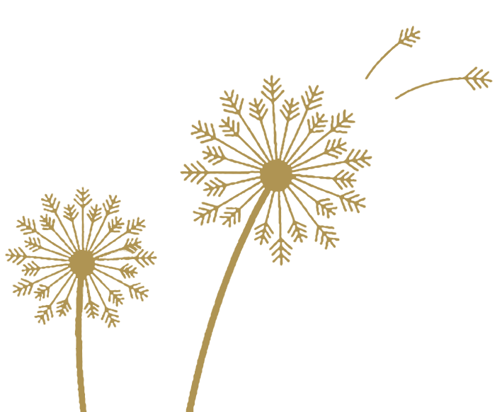
ROD PIANEGONDA

QUOTES

This is a list and selection of quotes on death, it's legacy and beauty - from prominent figures throughout history. Some have been referenced with dates. This list is constantly being updated.

The material presented on this website is within the Public Domain, other material is freely available elsewhere on the Web, I do not hold, nor claim to hold the copyright on any poem, reading or music title presented on this website.

--------------------------------------------------------------------------------------------------------------------------------

You were born a child of light’s wonderful secret— you return to the beauty you have always been.
Aberjhani

Life was such a fragile thing? As delicate and as beautiful as a butterfly, as ephemeral as a sunset. Death is peaceful. Death is quiet, silent. It is calming.
Akanksha

Men are never really willing to die except for the sake of freedom: therefore, they do not believe in dying completely.
Albert Camus (1913-1960)

Life is measured by - the ones left behind? Or his Faith? By Love? or by the people aside you? Or it has no meaning at all?
Aman Jassal

Life is a dream. We wake up when we die
Bangambiki Habyarimana

Life is rather a state of embryo, a preparation for life; a man is not completely born till he has passed through death.
Benjamin Franklin (1706-1790)

Even death is not to be feared by one who has lived wisely.
Buddha

How can the dead be truly dead when they still live in the souls of those who are left behind?
Carson McCullers

Why this fuss about death? Use your imagination, try to visualise a world without death.
Charlotte Gilman

We all come and go. This universe is staying here with endless joy of welcoming and an infinite sadness of farewell.
Debasish Mridha

Death is a stripping away of all that is not you. The secret of life is to die before you die ? and find that there is no death.
Eckhart Tolle

The boundaries which divide Life from Death are at best shadowy and vague. Who shall say where the one ends, and the other begins?
Edgar Allan Poe (1809-1849)

The anguish of death hangs over and leads the human spirit to wonder about the mysteries of existence, man's destiny, life, the world.
E. Morin

Every man's life ends the same way. It is only the details of how he lived and how he died that distinguish one man from another.
Ernest Hemingway

We are such stuff as dreams are made on, and our little life is rounded with sleep.
Eugene O'Neill

You are given a life, a death. Understand both while living, and before dying. Or you'd have wasted a life, a death.
Fakeer Ishavardas

Dying is a troublesome business: there is pain to be suffered, and it wrings one's heart; but death is a splendid thing --a warfare accomplished, a beginning all over again, a triumph. You can always see that in their faces.
George Bernard Shaw (1856-1950)

There is no cure for birth and death save to enjoy the interval.
George Santayana

Rest is not quitting this busy career;
Rest is the fitting of self to its sphere.
Goethe (1789-1830)

When a great man dies, for years the light he leaves behind him, lies on the paths of men.
Henry Wadsworth Longfellow
Death is the dropping of the flower that the fruit may swell.
Henry Ward Beecher (1813-1887)

Lost yesterday, somewhere between sunrise and sunset
Two golden hours, each set with sixty diamond minutes.
No reward is offered, for they are gone forever.
Horace Mann

Death, like so much in life, is a lesson, which must be understood and cherished, not feared; it is a rite of passage we all must encounter at one time or another; it helps build our character and makes us stronger if we can endure its painful aftermath.
Imania Margria

When you were born, you cried and the world rejoiced. Live your life in such a way that when you die, the world cries and you rejoice.
Indian proverb

It matters not how a man dies, but how he lives. The act of dying is not of importance, it lasts so short a time.
James Boswell,

I'm not afraid of dying, I'm afraid of not living.
Jared Alexander

Here upon earth there is life, and then death, dawn, and later nightfall,
Fire, and the quenching of embers: But why should I not remember that my night is dawn in another part of the world, If the idea fits my fancy?
John Gould Fletcher

Our legacy is not found in all the 'stuff' we’ve accumulated on our life’s journey. It’s written in the memories of those whose lives we’ve touched along the way.”
Justin Young

Life and death issues are a universal concern. A person can learn about life by investigating the psychological and social aspects related to dying.
Kilroy J. Oldster

Life and death are one thread, the same line viewed from different sides.
Lao Tzu

While I thought that I was learning how to live, I have been learning how to die.
Leonardo da Vinci (1452-1519)

Death is not something you get over. It's the rip that exposes life in a before and after chasm, and all you can do is try to exist as best you can in the after.
Lily Graham

God's finger touched him and he slept.
Lord Alfred Tennyson (1809-1892)

Say not: I live today, I shall die tomorrow. Divide not reality between life and death. Say: now I live and die.
Marcel Schwob (1867-190)

The fear of death follows from the fear of life. A man who lives fully is prepared to die at any time.
Mark Twain (1835-1910)

Death does not come when the body is too exhausted to live. Death comes because the brilliance inside of us can only be contained for so long. We do not die. We pass on. Pass on the life burning through our throats. When you leave me, I will not cry for you. I will run into the strongest wind I can find and welcome you home.
Michael Lee

We trouble our life by thoughts about death, and our death by thoughts about life.
Michel de Montaigne

Death truly does have life, and walks with and lives through us every day.
Nicholas A. McGirr

Death is not the greatest loss in life. The greatest loss is what dies inside us while we live.
Norman Cousins

Death must be so beautiful. To lie in the soft brown earth, with the grasses waving above one's head, and listen to silence. To have no yesterday, and no to-morrow. To forget time, to forget life, to be at peace.
Oscar Wilde (1854-1900)

The real question is not whether life exists after death. The real question is whether you are alive before death.
Osho Rajneesh

No one knows whether death, which people fear to be the greatest evil, may not be the greatest good.
Plato (BC 427-BC 347)

It is the secret of the world that all things subsist and do not die, but retire a little from sight and afterwards return again.
Ralph Waldo Emerson (1803-1882)

Not by lamentations and mournful chants ought we to celebrate the funeral of a good man, but by hymns, for in ceasing to be numbered with mortals he enters upon the heritage of a diviner life.
Plutarch (46-120)

Life does find a way to create a balance somewhere between smiles and tears. And, like a pendulum's swing, life seldom stays in one place. Life keeps on moving until, one day, it stops.
Ralph Webster

I have come to know that death is an important thing to keep in mind — not to complain or to make melancholy, but simply because only with the honest knowledge that one day I will die I can ever truly begin to live.
R.A. Salvatore

To be what we are, and to become what we are capable of becoming, is the only end of life.
Robert Louis Stevenson (1850-1894)

Life is eternal, and love is immortal, and death is only a horizon; and a horizon is nothing save the limit of our sight.
Rossiter Worthington Raymond

Learn to light a candle in the darkest moments of someone’s life.
Be the light that helps others see; it is what gives life its deepest significance.
Roy T. Bennett

If life must not be taken too seriously -- then so neither must death.
Samuel Butler (1612-1680)

The final hour when we cease to exist does not itself bring death; it merely of itself completes the death-process. We reach death at that moment, but we have been a long time on the way.
Seneca (4 BC-65)

The goal of all life is death.
Sigmund Freud

The hour of departure has arrived, and we go our separate ways, I to die, and you to live. Which of these two is better only God knows.
Socrates (470 BC-399)

If you have a warm and caring heart, you're loved ones will ensure you never depart. For long after you've turned that final page you'll still be right there on centre stage.
Stanley Victor Paskavich

Death is the destination we all share, no one has ever escaped it. And that is as it should be because death is very likely the single best invention of life.
Steve Jobs

Each stage of your life is like petals of a flower, unfolding and opening until it comes to full bloom. You will blossom and then you die. But know that this is not your ending.
Summerlyn Guthrie

The only thing I regret about my life is the length of it. If I had to live my life again, I'd make all the same mistakes - only sooner.
Tallulah Bankhead

Life never really ends... It just changes. You never lose your loved ones,
you gain guardian angels.
Tanya Masse

You may break, you may shatter the vase if you will.
But the scent of the rose will hang around it still.
Thomas Moore (1779-1852)

All goes onward and outward, nothing collapses,
And to die is different from what any one supposed, and luckier.
Walt Whitman (1819-1892)

A good leg will fall. A straight back will stoop. A black beard will turn white. A curled pate will grow bald. A fair face will wither. A full eye will wax hollow. But a good heart is the sun and the moon.
William Shakespeare (1564-1616)

I am prepared to meet my Maker. Whether my Maker is prepared for the ordeal of meeting me is another matter.
Winston Churchill

